**MODULE 4**

**AUTHENICATION & AUTHORIZATION**

TASK 1 (pp. 1 - 3)

Create a simple Spring Web application with endpoint /study/v1/info with returns simple text:

After added spring security dependency and configuration of web security context:

Endpoint stopped being available without authorization.

After adding authorization header with correspondent data:

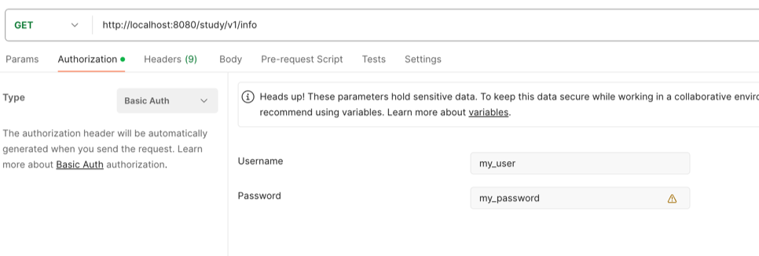

Endpoint started being available back:

TAKS 2 (pp. 4-6)

In-Memory auth does not work anymore:

Havin provided correct credentials we get access to endpoint:

Now let’s try to login under admin user with incorrect password:

And providing correct password we get access to the endpoint under admin user:

BUT, still the password is used as plain text what’s insecure.

Having installed Spring CLI and executed password encode commands:

So, now we can store the password in encoded format as bcrypt. Let’s update Liquibase script to replace password field.

Database table with users looks as follows:

Testing endpoint. With correct credentials for ADMIN user:

With incorrect credentials:

SA user

Admin user:

And with correct credentials for SA user:

Introducing new endpoint /study/v1/about with non-authenticated access:

Trying to call /study/v1/info in non-authenticated mode:

DENIED!

Setting up authentication mode ad providing credentials:

TASK 3 (pp. 7-11)

Arranged endpoints with the following authorizations:

/study/v1/about – non-authenticated mode

/study/v1/info – authenticated mode + requires role VIEW_INFO

/study/v1/admin – authenticated mode + requires role VIEW_ADMIN

The following users are pre-created and stand for verifications:

‘user_view’ has role VIEW_INFO

‘user_admin’ has role VIEW_ADMIN

‘user_view_admin’ has roles VIEW_INFO + VIEW_ADMIN

1. Endpoint ‘about’ does not require authentication:

1. Endpoint ‘info’ requires authentication and role VIEW_INFO:

Users ‘user_view’ and ‘user_view_admin’ can access it:

‘user_view’ accesses:

‘user_admin’ can’t access:

‘user_view_admin’ accesses:

1. Endpoint ‘admin’ requires authentication and role VIEW_INFO:

Users ‘user_admin’ and ‘user_view_admin’ can access it:

‘user_view’ can’t access:

‘user_admin; accesses:

‘user_view_admin’ accesses:

Having created Login form and configured Web Security to handle it for login and logout actions:

Providing incorrect credentials get error:

Populating with correct credentials:

We are redirected to page under authorization:

Logout will get us back to login page:

Demonstrating brute force protector.

Application property has setting of maximum login failure attempts as 3 times.

After 2 attempts of login with incorrect password user is not in blocked list:

Having made only at least 3 attempts for user ‘admin’ to enter password incorrectly we got that ‘admin’ is blocked.

Blocking is limited with 5 minutes.

It’s set in application properties:

So, at 15:39:17 user admin is activated again and goes from blocked list.

Still here as time has not passed.

Still blocked as time has not come yet.

And at expected time user admin goes unlocked.

